Install and use Chinese input in Ubuntu
Louis Lu, Aug 2016
System Settings → Language Support →

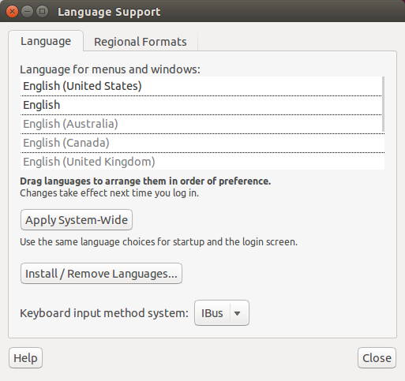

Select Install/Remove Languages...

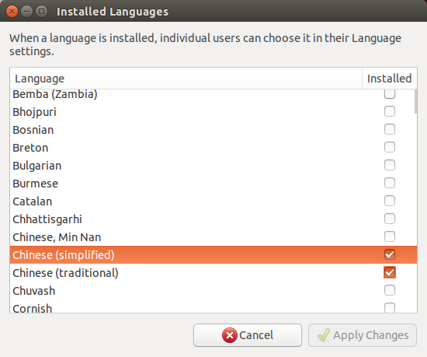
Just select the Chinese language you want and Apply Changes. Ubuntu will install the support.

After the install is done, click the language icon on the upper right corner, namely the En button below:

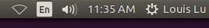
Select Text Entry Settings,
Click the “+” button to add Chinese (pinyin) input. Then, you can switch the English and Chinese inputs by using Win key + Space.
